- - Write Testable Code with Moq
Task 1
Interface definition (IMailSender.cs)
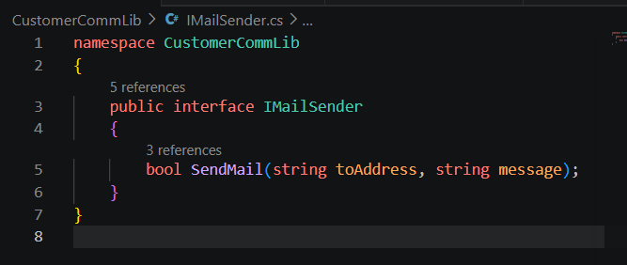
Implementation of MailSender class (MailSender.cs)
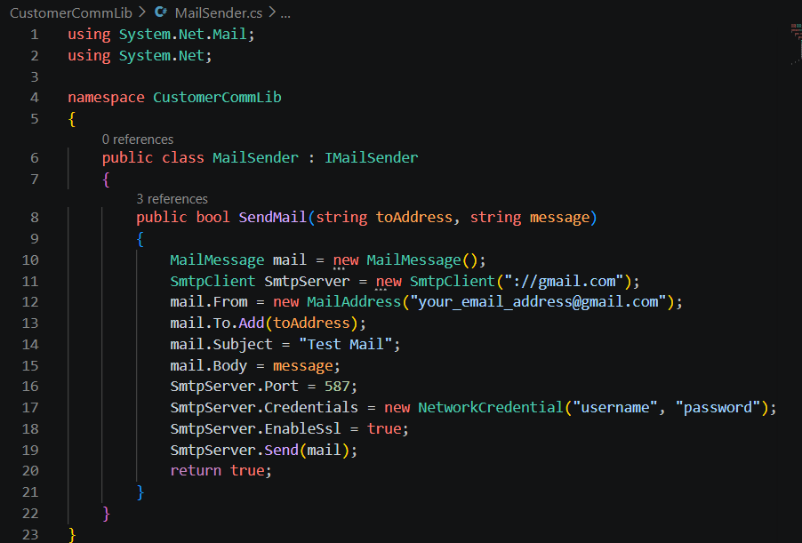

Class under test utilizing dependency injection (CustomerComm.cs)
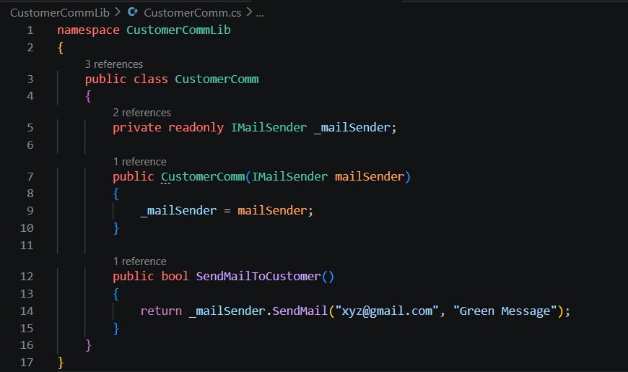
Task 2: Unit Testing with NUnit and Moq
Test Project Configuration
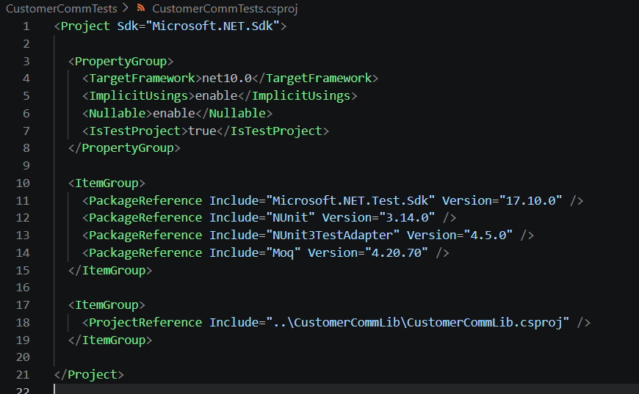
Complete Unit Test Suite Code (CustomerCommTests.cs)
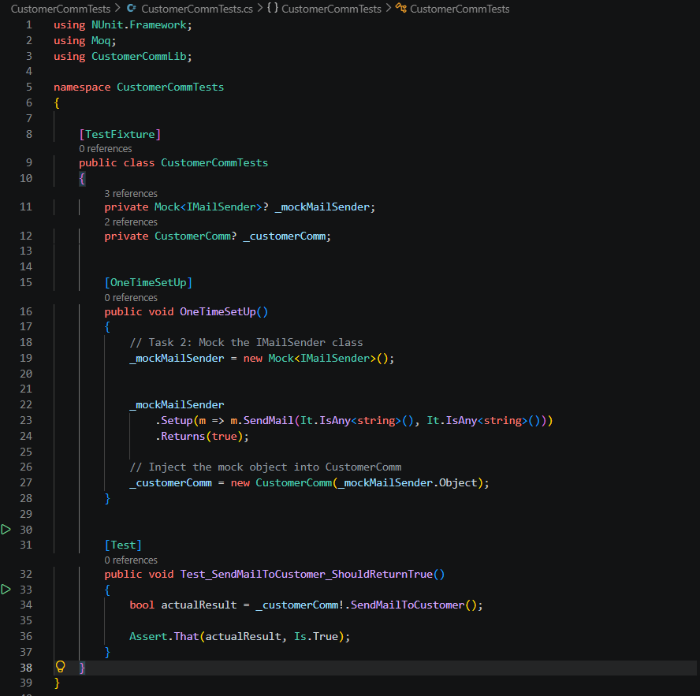
Code OUTPUT:
